
Address: 1503-A West Tower, Philippine Stock Exchange Building,
Exchange Road, Ortigas Center, Pasig City, Philippines
Tel.nos.: 6874445, 6873416, Telefax no.: 6874645
Mobile: 0917-5699639
Email: mbm@businessmaker-academy.com
Website: www.businessmaker-academy.com

Invest in yourself… Invest in Your People!

REGISTRATION FORM
Please fill in this form and fax back to Telefax: 6874645 or email to mbm@businessmaker-academy.com

SEMINAR TITLE: LABOR CODE AND PRACTICE
SCHEDULE: ________________________________________________________

Duration | Rate | Training Includes:
2 days  (9am to 5pm) | Regular Rate = Php 9,500 + 12%VAT = Php 10,640  Early Bird Rate = Php 8,500 + 12%VAT = Php 9,520  (early bird payment must be settled 8 days before actual class) | AM and PM snacks, drinks, sumptuous lunch, certificate, seminar kit and refresher session

CONTACT INFORMATION OF BOOKING OFFICER
Complete Name
Position
Company
TIN #
Office Address (in full)
Mobile No.
Telephone No.
Email Address
Fax Number

NAME(S) OF ATTENDEES
Complete Name | Nickname | Position | Mobile No. (for reminders) | Dietary Concerns Vegetarian / Food Allergies
1.
2.
3.
4.
5.
Note: Please add pages should you have more than 5 participants or call us to coordinate.

HOW TO ENROLL: LOCATION MAP:
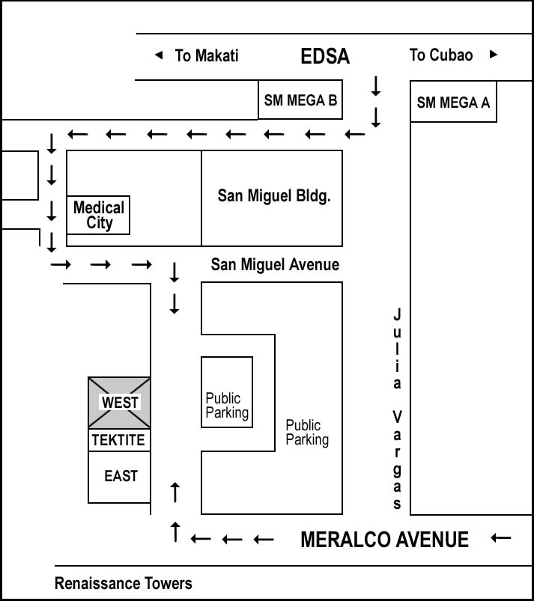
1 FILL UP THE REGISTRATION FORM
or you may call us directly at 6874445, 6874645, 6873416
to book a slot.

2 REMIT PAYMENT
You may settle enrollment fee via:
( ) CASH OR CHECK PAYMENT
Pls visit & pay at our office during office hours.
Pls make checks payable to Business Maker Academy, Inc.
( ) BANK DEPOSIT
Pls deposit payment to:
Savings Account Name: Business Maker Academy, Inc.
BPI Account No.: 4013-0306-64
BDO Account No.: 000-280-622-422
(Please fax deposit slip with your name and course to Telefax 6874645)
( ) PAYPAL
Pls remit payment to paypal@businessmaker-academy.com

3 Attend the class.
Please bring your deposit slip or receipt. Then enjoy learning!

IMPORTANT NOTE:
Business Maker Academy, Inc. is a VAT-registered company. TIN# 223-672-691-000 VAT
For zero rated or VAT exempt companies, please include your Certificate of Exemption. Provide Form 2307 or Certificate of Tax Withheld if payment done with tax withheld. Please withhold only 2% as we are classified as suppliers or contractors of services.

